

PRAGYAN HARDWARE HACKATHON

**Healthcare and Life Sciences**

**SPEAR**

**Soft Pneumatic Electromyographically Assisted Rehabilitation**

**Name** **College ID/Roll UG/PG** **Course/Branch Semester**

|  |  |  |  |  |
| --- | --- | --- | --- | --- |
| Name | Roll Number | UG/PG | Branch | Semester |
| Nitish Gudapati | 111117036 | UG | Mech | III |
| Koushik Kumaran | 108117056 | UG | ECE | III |
| Jinesh R | 107117045 | UG | EEE | III |
| Deepak S V | 107117033 | UG | EEE | III |
| Himadri Poddar | 110117035 | UG | ICE | III |
| Mukesh Kanna | 111117070 | UG | Mech | III |

1. **Project Abstract:**

Stroke patients often suffer from Foot Drop, a paralysis of the muscles in the anterior portion of the lower leg, causing an inability or impaired ability to raise the foot from the ankle. This leads to extremities of the foot dragging along the ground while walking, and can cause tripping and other accidents. Presently, patients are trained to walk with canes, and physiotherapy is also prescribed. The physiotherapy requires the presence of a trainer, and these frequent consultations lead to huge expenditure.

Currently, robotic therapeutic tools exist, but the rigidity does not lend itself to the compliant nature of the body, and are unwieldy. They are bulky and heavy which makes them unwearable under regular usage.

As a bio-inspired solution, SPEAR aims to provide a soft robotic approach to the physio therapy. The end effectors at the ankle are a set of soft pneumatic actuators, controlled by electromyographic signals (EMG). This achieves a reduction of weight at the joint, and can be custom made to fit the patient’s needs.

***Keywords — Rehabilitative robotics, stroke, foot drop, Soft robotics, soft pneumatic actuators, Electromyography***

1. **Proposed Design:**
2. **Objective:**

The objective is to rehabilitate patients with foot drop by fabricating a set of soft robotic actuators mimicking the muscle-skeleton system, controlled via electromyography (EMG) signals.

1. **Proposed Solution:**
   1. **Block Diagram:**

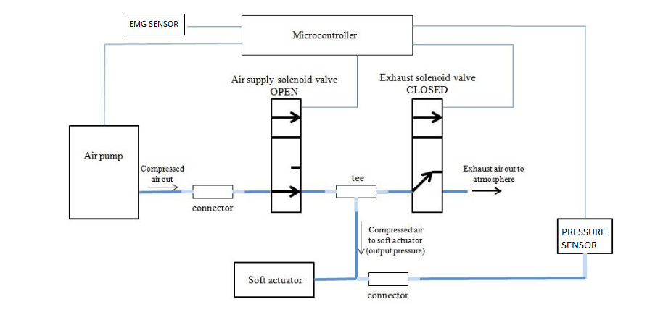

1. **Components Required:**

|  |  |
| --- | --- |
| COMPONENTS/PARTS | How is it being used in the proposed solution? Explain its role/functionality. |
| Thermoplastic Polyurethane / Silicone rubber tube, Nylon Mesh | Fabricate the pneumatic actuator |
| Air compressor | To compress the air from atmosphere and transfer the compressed air to pneumatic actuators |
| Solenoid Valve | To control the air flow to pneumatic actuators |
| MCU | To control the solenoid valve from the data obtained from the corresponding EMG sensors |
| Electromyographic (EMG) sensor | To measure the electrical activity of muscles |

1. **Innovativeness of the Proposed Solution**

Compared to other rehabilitative robots, a soft robot will be lighter, smaller and wearable. The soft nature of the robot, makes it more compliant with the human body, giving a great increase in comfort over existing solutions. The weight is also much less than that of a rigid structure, reducing the load on the ankle.

Electromyograph signals (EMG) eliminates the need for manual control, and makes the robot feel like a natural extension of the human body.

Compared to traditional therapeutic methods, the cost will be greatly decreased due to the one-time investment.

1. **Impact of the proposed solution (Application):**

Ease of physiotherapy for those affected with stroke. Physiotherapy is a costly and continuous process, whereas a robotics solution will be a one-time investment. Because of its compliant nature, SPEAR is lighter, smaller and easier to use, contrary to traditional rigid approaches.

1. **References**

<https://softroboticstoolkit.com>

<https://hpac.harvard.rdu/softrobotics>